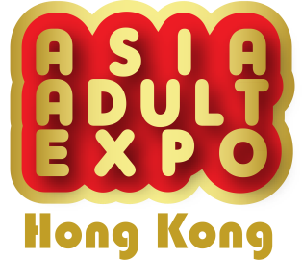
Press Release
19 January 2024

New Business Experience
Asia Adult Expo will be held at the Hong Kong Convention and Exhibition Center
from August 27 to 29, 2024

Asia Adult Expo (AAE) is an annual trade exhibition, a major event for the adult industry in Asia. AAE 2024 will be held at the Hong Kong Convention and Exhibition Center Hall 5FG from August 27 to 29, 2024 (Tuesday to Thursday). As the 14th international trade exhibition for the adult industry in the Asia-Pacific region, AAE not only retains the growth in net exhibition area from the previous edition, but also has a new trade experience for industry players this year. An online exhibitor list is launched before the exhibition, with more than 95% of exhibitors participating. Buyers can see the preview of exhibiting products on the AAE website, which is breaking through the limitations of previous physical exhibitions. Without the geographical boundaries, AAE further creates business opportunities.

The new online exhibitor list provides a wide range of products and services related to the adult industry, including sex toys, lingerie, lubricants, adult novelties and more. Exhibitors introduce the latest products and technologies through their web pages, and buyers can contact exhibitors directly without geographical restrictions. AAE provides effective and fast channels for many buyers sourcing and developing their business services.

Adult Expo Asia is a popular event in the adult industry, attracting thousands of professional buyers from the worldwide every year. In 2023, more than 300+ exhibitors and brands participated in AAE and more than 4,500 professional visitors came from 50 different countries and regions. It provides a unique opportunity for industry professionals to connect with each other and learn about the latest market trends and technologies. Up to the moment, more than 90% of the exhibition space has been sold out, and the number of exhibitors is expected to exceed the previous exhibition. It is an exhibition not to be missed in the industry.

With relevant industry business cards, you can enjoy free online pre-registration on the AAE official website www.asiaADULTexpo.com , which is valid until mid-August 2024. For press inquiries or independent AAE interview arrangements, please contact Ms. Niki Lam at (852) 2528 0062 or email info@asiaADULTexpo.com .
(On-site registration fee: HKD 200/USD 30 per person)

For exhibition information, please visit the official website www.asiaadulexpo.com .

Contact： Ms. Niki Lam Organizer Official Supportor
Tel： +852 2528 0062
Fax： +852 2528 0072
Email： info@asiaADULTexpo.com 亞洲成人博覽 組委會
Website：www.asiaADULTexpo.com

