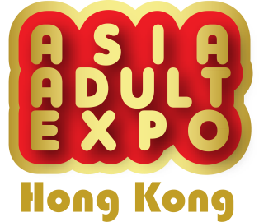
Press release
11 April 2024

FULL House at old halls!
Extra Space at the same level open for booking NOW!

Asia Adult Expo (AAE) is an annual trade show, a remarkable event for the adult industry in Asia. With the support of many exhibitors and adult industry, in addition to retaining the original Hong Kong Convention and Exhibition Center Exhibition Hall 5FG, AAE 2024 will expand to Hall 5E at the same level and will be held from August 27 to 29, 2024 (Tuesday to Thursday).

The new exhibition hall 5E will provide more than ​​6,500 square meters exhibition area, which can accommodate more exhibitors and professional visitors. The VIP/Buyer Lounge Area will be moved from the original exhibition hall to the new exhibition hall 5E. There are multiple display areas provided for exhibitors to introduce the latest products and technologies, and to display a series of various products and services related to the adult industry, including sex toys, lingerie, lubricants, adult novelties etc. For more exciting program arrangements, you may pay attention to the latest news on the website and social platforms.

Hall 5E is equipped with private meeting rooms to facilitate communication between exhibitors and buyers, improving privacy with some spacing. The facilities can be used by buyers free of charge but need prior booking on site. At the same time, AAE Global Partners also enjoy on-site priority appointment service to ensure that buyers from all over the world can enjoy premium business services.

With relevant industry business cards, you can enjoy free online pre-registration on the AAE official website www.asiaADULTexpo.com, which is valid until mid-August 2024. For press inquiries or independent AAE interview arrangements, please contact Ms. Niki Lam at (852) 2528 0062 or email info@asiaADULTexpo.com.
(On-site registration fee: HKD 200/USD 30 per person)

For exhibition information, please visit the official website www.asiaadulexpo.com.
Contact： Ms. Niki Lam Organizer Official Supportor
Tel： +852 2528 0062
Fax： +852 2528 0072
Email： info@asiaADULTexpo.com 亞洲成人博覽 組委會
Website：www.asiaADULTexpo.com

