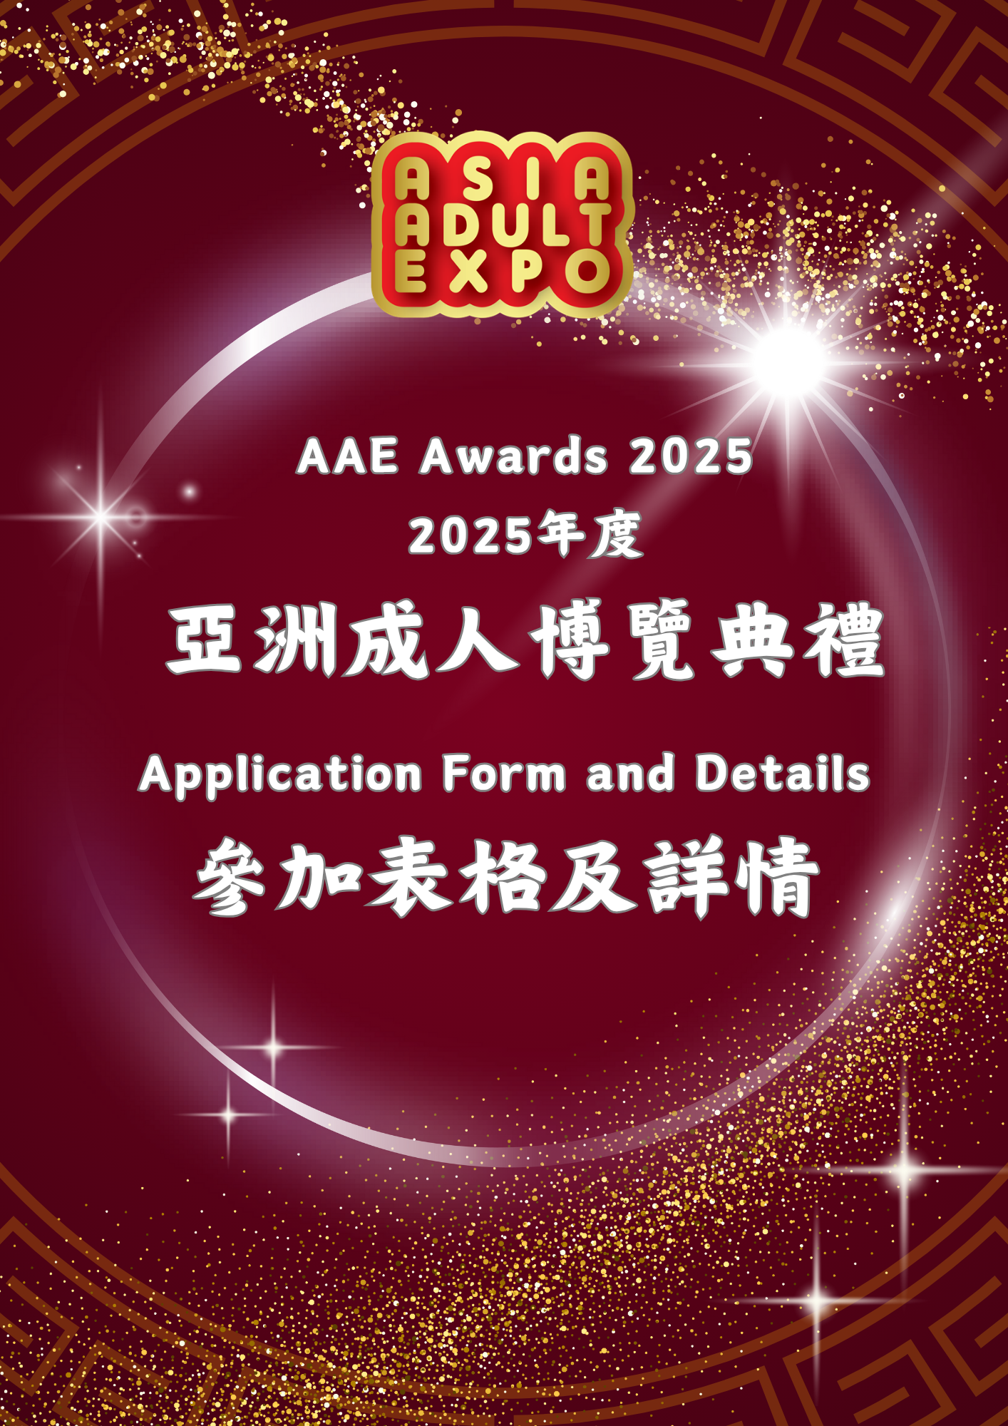

**INTRODUCTION 簡介**

**Purposes and Significances of AAE Awards**

1. Promote and encourage Adult industry / enterprises at international to actively involve and participate in the industry, to promote sustainable development and to become more professional.
2. To recognize enterprises which continuously seek breakthroughs, innovations and new ideas in the industry, cultivates talents and contributes to the community.
3. To enhance the image and social status of the adult industry and recognize the outstanding enterprises and practitioners at international.
4. To promote interactions and idea exchange; to speed up and enhance the overall industry development.

**Eligibility**

1. Must be engaged in adult industry related business, ie. Adult Products Manufacturers, Distributors, Retailers, Brand Owners, etc.
2. Enterprises’ business or service should be provided in international level with export oriented.

**Entries**

1. A company can select a service in its business to participate, for examples, Novelties, Lingerie, Love Products, Product line, or adult video, or
2. The entire company business.

**Benefits to Participating Companies**

1. To enhance the brand and image of the corporate within the industry, and to increase international exposure.
2. To increase the cohesion within the enterprise and to spark enthusiasm and morale among staffs.
3. Winning units can use the AAE Awards title on their publicity materials.

**Pre & Post Show Promotion**

1. AAE official website: special reports, website hyperlinks.
2. Social network: Facebook, Twitters, Linkedin, Wechat, etc.
3. Regular e-newsletter.
4. Press releases dispatch to international adult industry players and professional journals, newspapers and media.

**Promotion during Convention**

1. Fairground: display panel and catalogues listing.
2. AAE Awards ceremony held on 26 August,2025.

**Judging Panel**

1. Formed by leading professionals of international adult communities.
2. Members of the judging panel cannot nominate themselves or their institutions for the awards.

**『AAE成人產業大獎』(AAE Awards) 目的及意義**

1. 推動及鼓勵國際業界更積極投入及參與產業，推動國際成人產業發展，邁向更專業化。

2. 表揚一直推動業界，不斷尋求突破創新，為業界注入新思維，不斷自我完善之產業與者。

3. 提升成人產業在國際社會地位及形象，表揚出色企業及業者。

4. 加強業界交流，促進觀摩學習。

**參加資格**

1. 必須為從事或提供成人產業產品或服務機構，例如: 成人用品製造商、分銷商、零售商、品牌商等。
2. 公司業務為國際性，即為出口主導。

**參賽項目**

1. 公司可在旗下業務選取個別產品或服務參加 : 如成人玩具、內衣，情趣產品、產品線或成人影片或
2. 公司的整體業務。

**參加企業的獲益**

1. 提升及增強企業、品牌在世界的知名度及品牌形象，增加在業內及國際的曝光率。
2. 凝聚企業內部，提升士氣。
3. 得獎企業可在公司宣傳物料上使用得獎名銜，並獲得國際層面推廣機會。

**展會前後宣傳**

1. AAE網站: 專頁報導、網站連結。
2. 電子平台:　Facebook，Twitters，Linkedin領英，騰訊微信平台等。
3. 定期電子郵件、專題報導。
4. 發放新聞稿予國際成人業界人士、專業業界期刊、報章及媒體等。

**展會期間宣傳**

1. 頒獎典禮於2025年8月26日舉行。

**評審團**

1. 由AAE組委會組成以保持專業及中立性。
2. 評審團成員不能提名。

**Application Form參加表格 (Appendix 1 附表一)**

*Please complete the application form in **BLOCK** letters and email to [info@asiaADULTexpo.com](mailto:info@asiaADULTexpo.com).

請以**正楷**填寫以下各項後，把參加表格發送到電郵[info@asiaADULTexpo.com](mailto:info@asiaADULTexpo.com)**。**

**Company Information 公司資料**

|  |  |  |  |
| --- | --- | --- | --- |
| **Company Name**  **公司名稱** |  | | |
| **Authorized Person**  **負責人姓名** | **/Ms./Mrs.(** Please delete where appropriate)  **/小姐/女士(請刪去不適用者)** | | |
| **Job Title職銜** | General manager grade or above/職級總經理或以上 | | |
| **Address地址** |  | | |
| **Country國家** |  | **Company Website公司網址** |  |
| **Tel電話** | **-****-** | **Fax傳真** | **-     -** |
| **Email電郵** |  | **Mobile手機號碼** | **-** |

**Award Categories 獎項類別**

|  |  |  |  |  |
| --- | --- | --- | --- | --- |
| **Categories類別** | **Please fill in the award 請填上獎項** | | | |
| **1. First Choice首選:** | | **2. Second Choice次選:** | |
| **Contact person聯絡人** |  | **Job Title職銜** | |  |
| **Email電郵** |  | **Tel電話** | | **-     -** |

|  |  |
| --- | --- |
| Authorized Signature &  Company Stamp:  負責人簽署及公司印鑑: |  |

***Inquiry: Email電郵:*** [***info@asiaADULTexpo.com***](mailto:info@asiaADULTexpo.com) ***Subject標題註明: AAE Awards 2025 Inquiry 查詢: (852) 2528 0062***

**Payment Method: 付款方法: All cheques / bankdrafts / telegraphic / transfers should be made to : 請將支票 / 銀行匯票 / 電匯(T/T) 開至:**

Organizer公司名稱 : Brilliant Vertical Exhibition (Hong Kong) Limited香港美縱展覽有限公司

Bank name銀行名稱: Bank of China (Hong Kong) Limited 中國銀行(香港) USD Saving Account: 帳號(美元): 012 - 600 2 023658 1

Bank 銀行swift code: BKCHHKHHXXX Bank address銀行地址: 1 Garden Road, Hong Kong香港花園道一號

*Please fax or email this form and Bank receipt to請將此表及匯款通知書傳真至 (852) 2528 0072 or info@AsiaFuneralExpo.com*

*All payment must be made in USD currency only. All banking charges are to be paid by the client所有款項應以美元支付，所有銀行手續費應由匯款人承擔。*

**Award Categories details Form參賽項目資料表格** (Appendix 2 附表二)

*Please complete the application form in **ENGLISH** and email to [info@asiaADULTexpo.com](mailto:info@asiaADULTexpo.com).

請以**英文**填寫以下各項後，把參加表格發送到電郵[info@asiaADULTexpo.com](mailto:info@asiaADULTexpo.com)**。**

|  |
| --- |
| **Corporate Concept企業理念** |
| Company Profile 公司簡介  - Company Background/History 公司背景/歷史  - Company Mission & Vision公司使命與願景 |
| *(limit 300 words不多於300字)* |
| **Innovation創新意念** |
| What is the concept for the design of this Product / Product Line / Brand??  為什麼會有這產品 / 產品系列 / 品牌 的設計概念?? |
| *(limit 300 words不多於300字)* |

|  |
| --- |
| Description the Product / Product Line / Brand 請形容一下產品 / 產品系列 / 品牌?? (limit 300 words)  - How the products’ functions match with the design concept? 產品 / 產品系列 / 品牌有什麼功能如何帶出本身的設計概念??  - How different products uniqueness make the balance within the products line?? 產品系列中的產品如果發揮不同的功能以達至設計概念??  - How is the product unique compare with others? 產品與其他產品相比有什麼獨特性/特出的地方?? |
| *(limit 300 words不多於300字)* |
| **Marketing Strategy市場營銷策略** |
| How do the Product / Product Line / Brand has been / will be promoted to the world market? (limit 300 words)  - What is the overall promotion plan?? 有關整體的宣傳計劃  - is there any different marketing promotion in different country?? 在不同國家的宣傳有沒有不受的推廣方法??如不同，請說明。 |
| *(limit 300 words不多於300字)* |
| **Compulsory必須**  *Provide Related Photo of the Product / Product Line / Brand*  *請一同提供相關產品 / 產品系列 / 品牌 的圖片 (Photo Format相片格式: JPG/PNG - 300dpi or 1MB or above或以上)* |

**APPLICATION GUIDE參加指引**

|  |  |
| --- | --- |
| **Eligibility**   1. Must be engaged in adult industry related business, ie. Adult Product Manufacturers, Distributors, Retailers, Brand owners, etc. 2. Enterprises’ business or service should be provided in international level with export oriented.   **Entries**   1. A company can select a service in its business to participate, for examples, Novelties, Lingerie, Love Products, Product line, or adult video, or 2. The entire company business.   **Enrollment Procedures**   1. Fill in the application form (Page 3-5 - Appendix 1 & 2) and return to the organizer via email. 2. The participation fee is USD1,000/application (for AAE2024 exhibitor). 3. Results will be announced 1-2 weeks before show begin.   **Promotion Activities for Winning Unit …**  In order to enhance promotional opportunities and to encourage interaction among the industry players, the organizer will:   1. Prepare on-site display panel to show the winners of the Awards, with Company Name, Logo, Booth no., and its winning category(ies). 2. Feature the winners on the website with Company Name, Logo, and its winning category(ies). 3. Mention all awards winners on the post show press release and send to media and industry players.   **AAE Awards Ceremony**   1. AAE Awards Ceremony will be held on 26 August 2025 during opening period of AAE at the stage. Dress code will be business attire (black tie optional). 2. In the ceremony, the trophy will be presented, winning unit will be introduced and each winning unit will have a chance to present their acceptance speech. 3. Press release will be dispatched.   **Rules & Regulations**   1. To avoid affecting the assessment progress, no amendment is allowed for any submitted proposal/presentation. 2. No late submission is permitted, no refund policy. 3. Each applicant can apply more than one awards.   Each Award application needs to submit separated application form and participation fee.   1. Applicants must ensure that all personal data entered are true and correct. They must not infringe on the rights of others (including copyright). Before the results are announced, submitted works must not be published in any form through the media or other avenues (including online or print publication), otherwise will be disqualified. 2. The organizer has the right to exhibit in the event and upload the winning units on the AAE website. 3. The organizer reserves the right to amend the regulations, judging criteria and result of the contest without informing participants in advance. The decisions of the judges are final and cannot be appealed. 4. The final decisions on the competition shall rest with the organizer who may amend the terms and conditions, awards or any other arrangements concerning the competition at any stage without informing applicants. | **參加資格**   1. 必須為從事或提供成人產業產品或服務機構，例如:成人用品製造商、分銷商、零售商、品牌商等。 2. 公司業務為國際性，即為出口主導。   **參賽項目**   1. 公司可在旗下業務選取個別產品或服務參加 : 如成人玩具、內衣，生活情趣產品、產品線或成人影片或 2. 公司的整體業務。   **參加辦法及報名程式**   1. 填寫申請表 (第三至五頁 - 附表一及二)將填妥的表格電郵回主辦單位。 2. 報名費用為每次申請1,000美元(只限AAE2025參展商)。 3. 公佈結果 : 約在展會開始前1至2星期。   **得獎單位推廣及宣傳活動**  為加強業界交流、增強得獎機構宣傳機會及提升傳媒採訪率。大會將於:   1. 會場中特設『AAE頒獎典禮』展示板，展示公司名稱、LOGO、攤位號碼以及得獎項目；讓買家可以到得獎機構的攤位了解更多。 2. 網頁上將會展示得獎的公司名稱、LOGO以及得獎項目。 3. 展後的新聞發佈上列出各獎項的得獎機構，並發到媒體及業界人士。   **AAE頒獎典禮**   1. 頒獎禮將在2025年8月26日假座AAE展會會場，出席者均需以正裝出席。 2. 在典禮中會介紹得獎企業，並頒發獎座，得獎者將有機會宣讀得獎感言。 3. 廣發新聞稿。   **參加規則**   * 1. 為免影響評審進度，已遞交了的計劃書或展示報告，恕不接受任何更改申請。   2. 所有的計劃書或展示報告必須在截止日期前遞交，否則作放棄參加。已交的報名費，恕不退回。   3. 每位參賽者可申請多於一個獎項。   每個獎項申請需個別呈交計劃書及繳付申請費用。   * 1. 參賽者提供的資料必須真實無訛，亦無侵犯他人的權益（包括版權）。結果公佈前，參賽者不得以任何方式於任何媒體或途徑發表（包括網上或出版），否則參加或得獎資格將被取消。   2. 主辦機構有權將得獎計劃書上載至AAE網頁、在展會等公開場合展示。   3. 主辦機構保留對比賽規則、評審準則和結果的最終修訂權和決定權，如有更改恕不另行通知。比賽結果一概以評審團之最終決定為準，任何人不得異議。   4. 主辦機構將保留一切有關活動之最終決定權，包括更改此活動的條款及細則、獎項及其他安排，而不需另行通知。 |